Handout for owners- Spondylosis
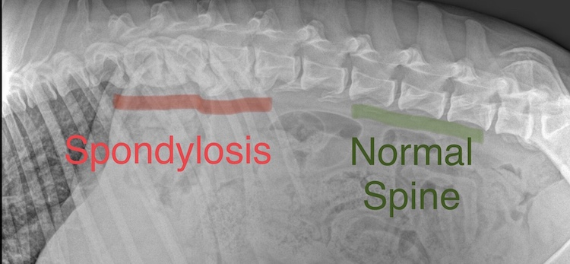

Spondylosis is a condition of the spine, where new bone is formed, between the vertebrae.

It can be a common finding, especially in older cats, and can be linked to spinal arthritis, pain and inflammation of the spinal area. Nerves can sometimes become trapped, or inflamed, from the “bridges” of bone.
Depending on where it is along the spine, it can affect the limbs linked to that area. For example, the thoracic spine is near to the nerves that affect the front legs, while lumbar spinal spondylosis may affect back legs. In older or overweight cats, it can be quite pronounced and cause obvious discomfort.

However, it can also be an “accidental” finding and not appear to cause any problems in some cats. We don’t fully understand why it happens, though obesity and age can worsen it.

Managing spondylosis in cats is very similar to managing arthritis- in the early stages, joint supplements can be helpful, to help lubricate the cartilage within the joints. Sometimes non-steroidal anti-inflammatory drugs (NSAIDs) are needed, long term, to resolve chronic inflammation and reduce pain. Some pain killers are designed to reduce nerve inflammation, and these can be used in addition to NSAIDs, in more severe cases.

Preventing the cat from becoming overweight is vitally important, to reduce the load on the spine and joints. Keep them active with gentle play and activity, that is within their ability and make sure they are fed a diet that has a high-quality protein source, to help prevent muscle loss.
Ongoing treatment for these conditions is covered under our part-foster scheme, with 6 monthly health checks with our vet, IF prescription medication is needed.

Any further questions, please do ask the animal care team, or contact us.
Having this condition may or may not affect your pet insurance. The rescue centre is not able to be responsible for what pet insurance companies will cover.

